**US - Source URL Analysis**

**URL:** <https://www.govinfo.gov/>

GovInfo is a service of the United States Government Publishing Office (GPO), which is a federal agency in the legislative branch. It provides free public access to official publications from all three branches of the Federal Government.

In addition to providing an advanced, metadata-powered search experience, GovInfo also includes a content management system and a standards-compliant preservation repository.

(It is important to note that the legislation available via this link covers only the period from 1995 to 2025.)

Aside from the basic search, the homepage has an [Advanced Search](https://www.govinfo.gov/#advanced) option (1) where you may filter the search by *Date Range (2)*, *Refine by Collection (3)*, and *Search in full text, branch, category, government author, series, sudoc class number, title, associated bill citation, citation, congress number, law number, law type, legislative history, statutes at large citation,* and *United States code citation (4)*.

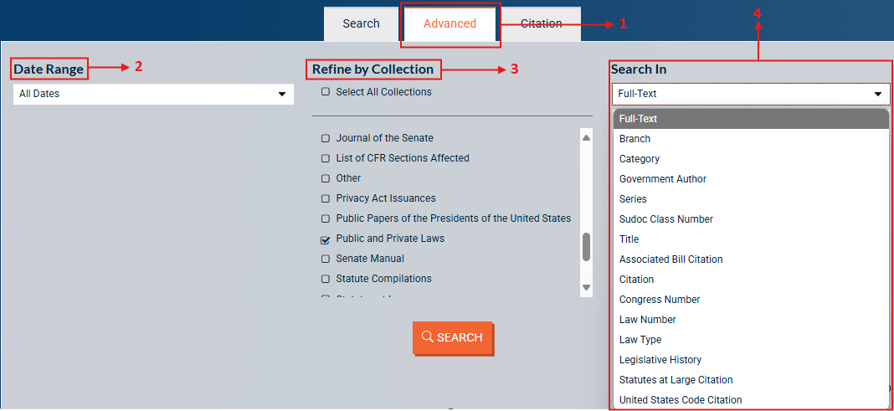

Use the advanced search option by filtering the search by title or full text (A), entering the keyword or keywords in (B), and then refining by collection by choosing Acts (public and private laws) as the type of regulation (C).

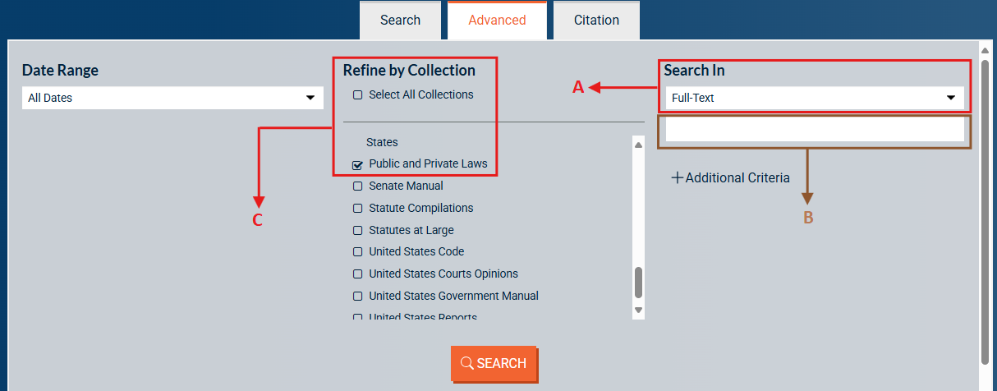

Please take note that there are results in the Search In if we enter the keyword and filter it into Full-Text (1). However, there are no results if we apply the same term to filter it into Title (2)**.** Please find an example below (2nd and 3rd screenshot):

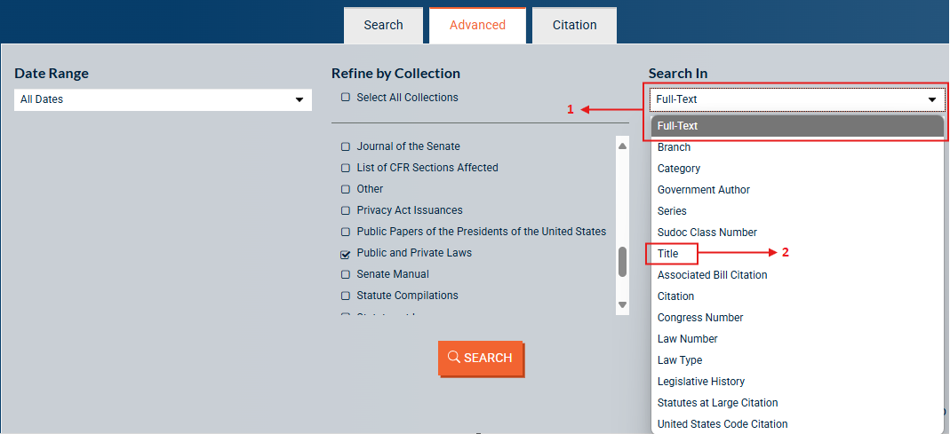

**Full-Text:**

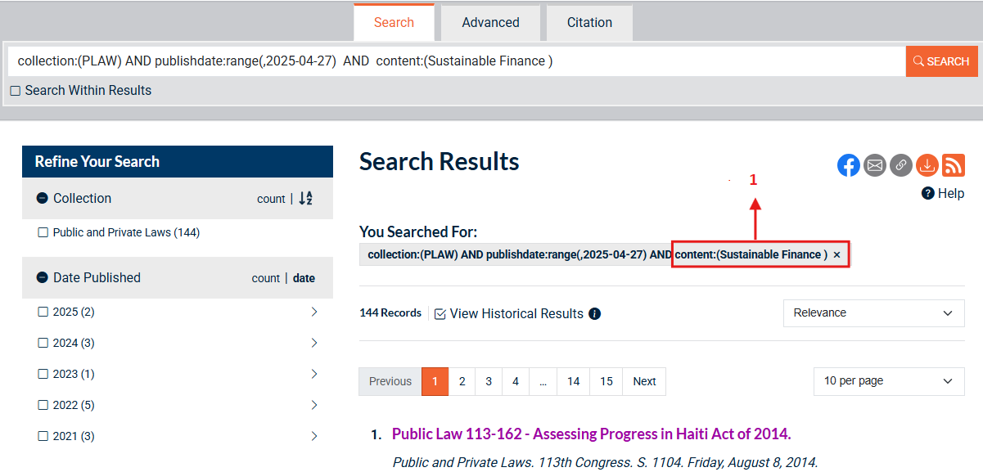

**Title:**

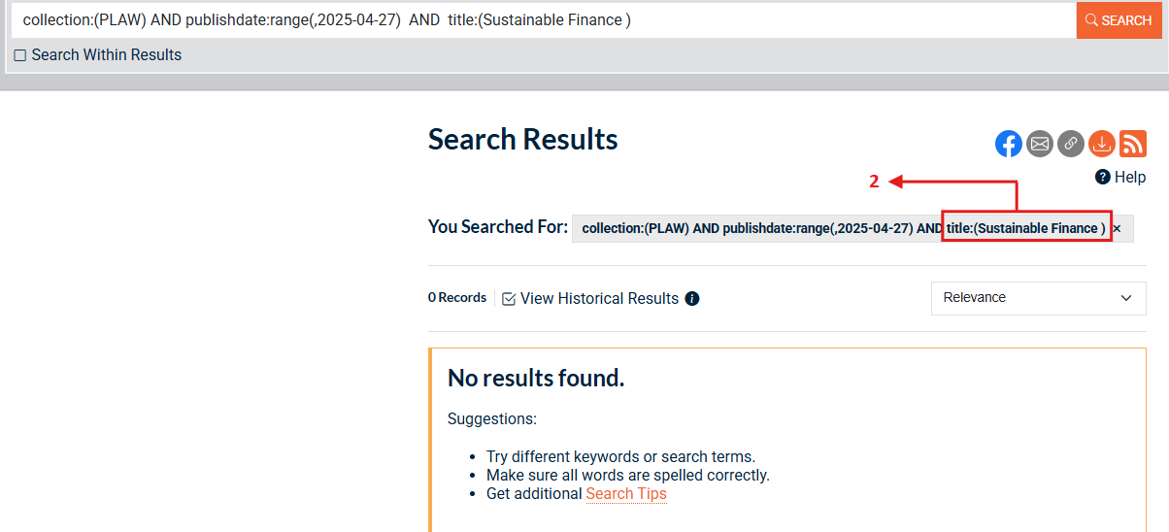

The necessary metadata is included in the site's content on the result page (apart from the date of adoption).

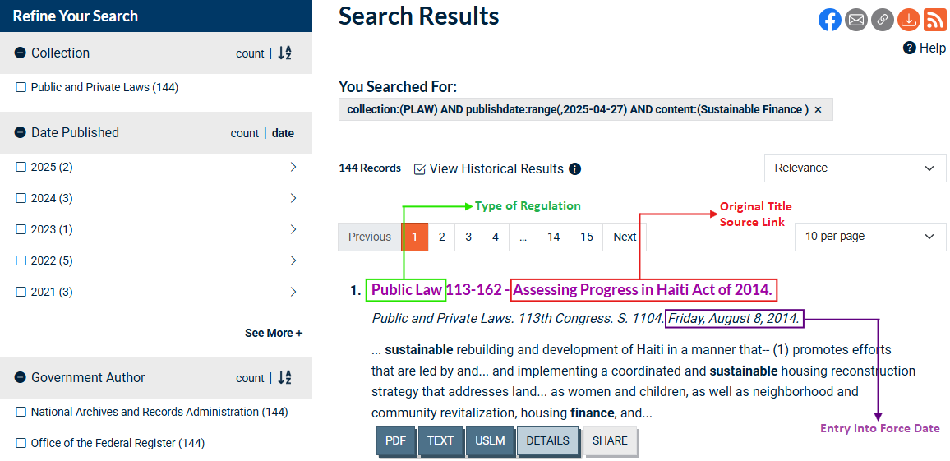

To find the date of adoption, we must navigate to the individual legislation page, which is located at the top of the page under Bill Versions of the Related Documents tab.

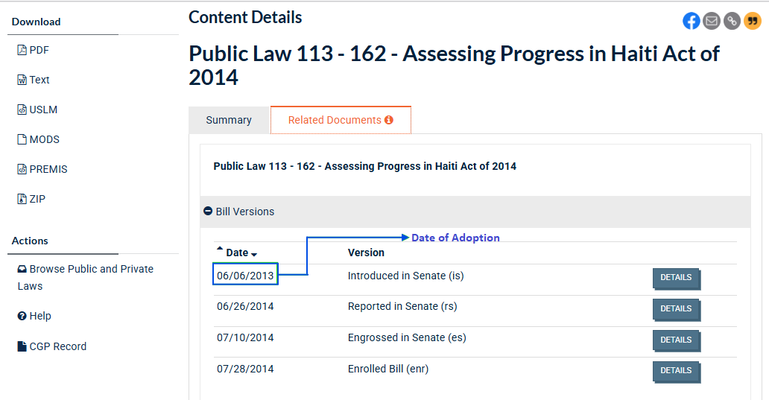

The keywords or subtopics from the Title or Content fields can be entered in the Search field, depending on which yields the most pertinent results.

**US - Alternative**

URL: <https://www.congress.gov/advanced-search/legislation>

Aside from the basic search bar, there is an advanced search bar (1).

, Picture

Filter the following:

Choose the dates in (1); enter the keyword or keywords in (2); select all legislation type in (3), choose the *Public and Private Legislation* in (4), and then filter into *Laws* in (5).

, Picture

, Picture

, Picture

In the result page, all the necessary metadata (used the keyword *Pollution*) is visible.

, Picture

Filter the scraping output (title) to items that contain only the list of keywords.